**Installing pir motion sensor on a breadboard (guide)**

Info: in this step by step test guide I will explain how to install a pir sensor on a breadboard. There will of course be pictures to help you with this test guide. The photos also make the test guide shorter and clearer for the person who wants to perform this installation.

Step 1:

What do you need:

3x jumping wires (male to male)

1x pir motion sensor

1x breadboard

1x 9v battery

2x connecting cables

3x jumping wires (female to male)

Step 2:

First you are going to install the pir motion sensor on the breadboard. Follow the steps in this photo to complete this installation process:

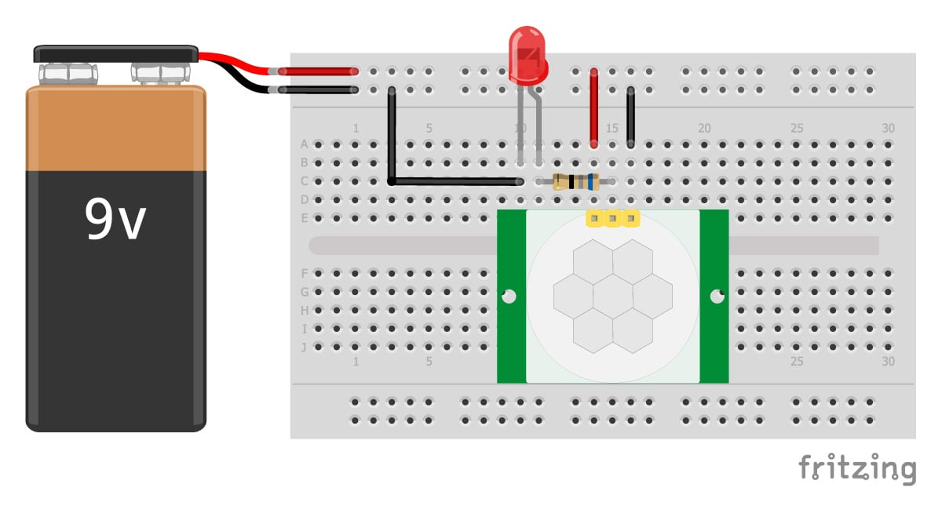

Step 3:

Everything should work now. If not, you should check the cables and see if you can install them better. After that, everything should work as indicated.

This is how the final product should look like:

